ABSTRACT

This project aims to develop and evaluate machine learning models for detecting emotions in text data. The project utilizes a dataset of annotated text samples and applies various preprocessing and feature extraction techniques to represent the text data in a suitable format for classification. Several classification algorithms, including Naive Bayes and Support Vector Machines (SVM), are employed to train models to predict. The performance of the models is evaluated using standard metrics such as precision, RMS, and r2 score.

Idea Behind Project

The Housing Price Prediction project aims to leverage data science and machine learning techniques to develop an accurate model for predicting housing prices. In a world where housing is a fundamental necessity, the real estate market plays a crucial role in the global economy. This project addresses the need of a US-based housing company, Surprise Housing, which intends to enter the Australian market.

The project's primary objective is to build a predictive model that estimates the actual value of prospective properties. By doing so, the company can make informed decisions on property purchases, selling at higher prices, and maximizing profits. Leveraging the power of data analytics, the model identifies key variables that impact housing prices, providing insights into market trends and influencing factors.

Through extensive Exploratory Data Analysis (EDA), the project uncovers relationships between different variables and the price of houses. Visualizations like scatter plots, histograms, and box plots reveal unique patterns, helping in feature engineering and data cleaning. Applying machine learning algorithms, such as Random Forest and Gradient Boosting, the model learns from historical housing data, thereby predicting prices more accurately.

The project's outcome not only assists Surprise Housing in making strategic decisions based on market dynamics but also enriches the understanding of pricing dynamics in a new market. The success of this project hinges on the fusion of data science techniques with real estate economics, contributing to improved revenue generation, enhanced marketing strategies, and better investment decisions for housing companies worldwide.

Technologies Learnt and Used
PYTHON
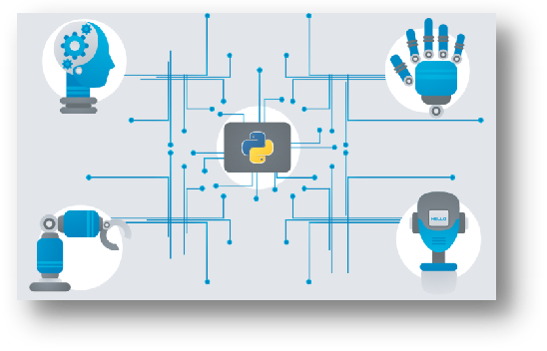
Python is a general-purpose interpreted, interactive, object-oriented, and high-level programming language. It was created by Guido van Rossum during 1985- 1990. Like Perl, Python source code is also available under the GNU General Public License (GPL). This tutorial gives enough understanding on Python programming language.
U7Python is a high-level, interpreted, interactive and object-oriented scripting language. Python is designed to be highly readable. It uses English keywords frequently where as other languages use punctuation, and it has fewer syntactical constructions than other languages.
Python is Interpreted − Python is processed at runtime by the interpreter. You do not need to compile your program before executing it. This is similar to PERL and PHP.
- Python is Interactive − You can actually sit at a Python prompt and interact with the interpreter directly to write your programs.
- Python is Object-Oriented − Python supports Object-Oriented style or technique of programming that encapsulates code within objects.
- Python is a Beginner's Language − Python is a great language for the beginner-level programmers and supports the development of a wide range of applications from simple text processing to WWW browsers to games.
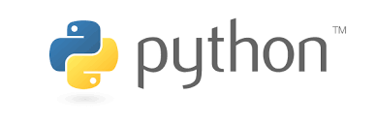

History of Python

 Picture of the Creator of Python - Guido van Rossum
Python was developed by Guido van Rossum in the late eighties and early nineties at the National Research Institute for Mathematics and Computer Science in the Netherlands.
Python is derived from many other languages, including ABC, Modula-3, C, C++, Algol-68, SmallTalk, and Unix shell and other scripting languages.
Python is copyrighted. Like Perl, Python source code is now available under the GNU General Public License (GPL).
Python is now maintained by a core development team at the institute, although Guido van Rossum still holds a vital role in directing its progress.
Python's features include −
- Easy-to-learn − Python has few keywords, simple structure, and a clearly defined syntax. This allows the student to pick up the language quickly.
- Easy-to-read − Python code is more clearly defined and visible to the eyes.
- Easy-to-maintain − Python's source code is fairly easy-to-maintain.
- A broad standard library − Python's bulk of the library is very portable and cross-platform compatible on UNIX, Windows, and Macintosh.
- Interactive Mode − Python has support for an interactive mode which allows interactive testing and debugging of snippets of code.
- Portable − Python can run on a wide variety of hardware platforms and has the same interface on all platforms.
- Extendable − You can add low-level modules to the Python interpreter. These modules enable programmers to add to or customize their tools to be more efficient.
- Databases − Python provides interfaces to all major commercial databases.
- GUI Programming − Python supports GUI applications that can be created and ported to many system calls, libraries and windows systems, such as Windows MFC, Macintosh, and the X Window system of Unix.
- Scalable − Python provides a better structure and support for large programs than shell scripting.
Apart from the above-mentioned features, Python has a big list of good features, few are listed below −
- It supports functional and structured programming methods as well as OOP.
- It can be used as a scripting language or can be compiled to byte-code for building large applications.
- It provides very high-level dynamic data types and supports dynamic type checking.
- IT supports automatic garbage collection.
- It can be easily integrated with C, C++, COM, ActiveX, CORBA, and Java.

Real-world Applications of Python

1. Web Development
When it comes to web development, Python should be your go-to tool. Why?
That’s because Python offers numerous options for web development. For instance, you have Django, Pyramid, Flask, and Bottle for developing web frameworks and even advanced content management systems like Plone and Django CMS. These web frameworks are packed with standard libraries and modules which simplify tasks like content management, database interaction, and interfacing with internet protocols like HTTP, SMTP, XML, JSON, FTP, IMAP, and POP.
Python web frameworks are known for their security, scalability, and flexibility. To add to that, Python’s Package Index comes with useful libraries like Requests, BeautifulSoup, Paramiko, Feedparser, and Twisted Python.

2. Game Development
As we mentioned earlier, Python comes loaded with many useful extensions (libraries) that come in handy for the development of interactive games. For instance, libraries like PySoy (a 3D game engine that supports Python 3) and PyGame are two Python-based libraries used widely for game development. Python is the foundation for popular games like Battlefield 2, Frets on Fire, World of Tanks, Disney’s Toontown Online, Vega Strike, and Civilization-IV.
Apart from game development, game designers can also use Python for developing tools to simplify specific actions such as level design or dialog tree creation, and even use those tools to export those tasks in formats that can be used by the primary game engine. Also, Python is used as a scripting language by many game engines.

3. Scientific and Numeric Applications
Thanks to its massive library base, Python has become a crucial tool in scientific and numeric computing. In fact, Python provides the skeleton for applications that deal with computation and scientific data processing. Apps like FreeCAD (3D modeling software) and Abaqus (finite element method software) are coded in Python.
Some of the most useful Python packages for scientific and numeric computation include:
- SciPy (scientific numeric library)
- Pandas (data analytics library)
- IPython (command shell)
- Numeric Python (fundamental numeric package)
- Natural Language Toolkit (Mathematical And text analysis)

4. Artificial Intelligence and Machine Learning
AI and ML models and projects are inherently different from traditional software models. When we talk about AI/ML projects, the tools and technologies used and the skillset required is totally different from those used in the development of conventional software projects. AI/ML applications require a language that is stable, secure, flexible, and is equipped with tools that can handle the various unique requirements of such projects. Python has all these qualities, and hence, it has become one of the most favored languages of Data Science professionals.
Python’s simplicity, consistency, platform independence, great collection of resourceful libraries, and an active community make it the perfect tool for developing AI and ML applications. Some of the best Python packages for AI and ML are:
- SciPy for advanced computing
- Pandas for general-purpose data analysis
- Seaborn for data visualization
- Keras, TensorFlow, and Scikit-learn for ML
- NumPy for high-performance scientific computing and data analysis
Apart from these libraries, there are also other Python-based libraries like NLTK, Caffee, PyTorch, and Accord. NET, that are useful for AI and ML projects.

Desktop GUI
Python not only boasts of an English-like syntax, but it also features a modular architecture and the ability to work on multiple operating systems. These aspects, combined with its rich text processing tools, make Python an excellent choice for developing desktop-based GUI applications.
Python offers many GUI toolkits and frameworks that make desktop application development a breeze. PyQt, PyGtk, Kivy, Tkinter, WxPython, PyGUI, and PySide are some of the best Python-based GUI frameworks that allow developers to create highly functional Graphical User Interfaces (GUIs).

6. Software Development
Python packages and applications aim to simplify the process of software development. From developing complex applications that involve scientific and numeric computing to developing desktop and web applications, Python can do it all. This is the reason why Software Developers use Python as a support language for build control, testing, and management.
For instance, SCons is designed explicitly for build control, Buildbot and Apache Gump allow for automated continuous compilation and testing, and Roundup and Trac are great for bug tracking and project management.
Python also supports data analyzation and visualization, thereby further simplifying the process of creating custom solutions minus the extra effort and time investment.

7. Enterprise-level/Business Applications
Enterprise-level software or business applications are strikingly different from standard applications, as in the former demands features like readability, extensibility, and scalability. Essentially, business applications are designed to fit the requirements of an organization rather than the needs of individual customers.
Thus, these applications must be capable of integrating with legacy systems like existing databases and non-web apps. Since business applications are developed, keeping in mind the custom requirements to cater to the specific needs of an organization’s operating model, the entire development process becomes very complicated.
This is where Python can make a significant difference. Python high performance, scalability, flexibility, and readability are just the features required for developing fully-functional and efficient business applications. Furthermore, Python has other tools for business application development, like:
- Odoo, an all-in-one management software that forms a complete suite of enterprise management applications.
- Tryton, a three-tier, high-level, general-purpose application platform, is another fantastic tool for building business applications.

8. Education programs and training courses
If there’s any beginner-friendly programming language, it is Python. We’ve said it many times before, and we’re repeating it – Python has an extremely straightforward syntax that’s similar to the English language. It has a short learning curve and hence, is an excellent choice for beginners. Python’s easy learning curve and simplicity are the two main reasons why it is one of the most used programming languages in educational programs, both at beginner and advanced levels.
However, Python is not just great as an introductory language – even professional developers and coders all around the world rely heavily on Python.

9. Language Development
Over the years, Python’s design and module architecture has been the inspiration behind the development of many new programming languages such as Boo, Swift, CoffeeScript, Cobra, and OCaml. All of these languages share numerous similarities with Python on grounds like object model, syntax, and indentation.

10. Operating Systems
Yes, Python is the secret ingredient behind many operating systems as well, most popularly of Linux distributions. Linux-based Ubuntu’s Ubiquity Installer and Fedora and Red Hat Enterprise’s Anaconda Installer are coded in Python. Even Gentoo Linux leverages Python Portage (package management system). Usually, Python is combined with the C programming language to design and develop operating systems.

11. Web Scraping Applications
Python is a nifty tool for extracting voluminous amounts of data from websites and web pages. The pulled data is generally used in different real-world processes, including job listings, price comparison, R&D, etc.
BeautifulSoup, MechanicalSoup, Scrapy, LXML, Python Requests, Selenium, and Urllib are some of the best Python-based web scraping tools.

12. Image Processing and Graphic Design Applications:
Alongside all the uses mentioned above, Python also finds a unique use case in image processing and graphic design applications. The programming language is used globally to design and build 2D imaging software like Inkscape, GIMP, Paint Shop Pro, and Scribus. Also, Python is used in several 3D animation packages such as Blender, Houdini, 3ds Max, Maya, Cinema 4D, and Lightwave, to name a few.
INTRODUCTION TO DATA SCIENCE

Data science is an interdisciplinary field that involves using statistical and computational methods to extract insights and knowledge from data. The field has emerged in response to the explosion of data generated by modern technology, which has created a need for techniques to analyze and make sense of this data. Data science involves several different steps, including data collection, data preprocessing, data analysis, and communication of results. Data scientists use a variety of techniques and tools, including statistical models, machine learning algorithms, and visualization tools, to perform these steps. One of the key aspects of data science is the ability to identify patterns and trends in data, which can be used to make predictions and inform decision-making. Data scientists use techniques such as regression analysis, clustering, and classification to identify these patterns and make predictions based on them. Data science has a wide range of applications in industry, government, and academia. Some common applications of data science include marketing analytics, fraud detection, recommendation systems, and predictive maintenance in manufacturing. As the amount of data generated continues to grow, the field of data science is becoming increasingly important. Data scientists are in high demand, and the field is constantly evolving as new techniques and tools are developed.

WHAT IS DATA SCIENCE

Data science is an interdisciplinary field that involves using statistical and computational methods to extract insights and knowledge from data. The field encompasses a range of techniques, including data mining, machine learning, and statistical modeling, to analyze and make predictions from complex and often large datasets. Data science involves several stages, including data collection, cleaning, and preparation, exploratory data analysis, feature engineering, model building, and deployment. Data scientists use programming languages like Python and R, along with a variety of tools and frameworks, to perform these tasks. One of the key goals of data science is to uncover patterns and trends in data that can be used to make predictions and inform decision-making. Data scientists use a range of techniques such as regression analysis, clustering, and classification to identify these patterns and make predictions based on them. Data science has applications across a wide range of fields, including healthcare, finance, marketing, and government. It is used to solve complex problems, such as predicting disease outbreaks, detecting fraud, and recommending products or services to customers.

WHAT CAN DATA SCIENCE DO?
Data science can be applied to a wide range of fields and problems, and its applications are growing every day. Here are some examples of what data science can do:
- Predictive modeling: Data science can be used to build predictive models that can forecast future trends, behaviors, or outcomes. This can be useful in a variety of applications, such as predicting consumer demand for a product, forecasting sales revenue, or predicting equipment failures in manufacturing.
- Fraud detection: Data science can be used to identify patterns of fraudulent behavior and flag suspicious activity. This can help prevent fraud in financial transactions, insurance claims, and other areas.
- Recommender systems: Data science can be used to develop recommender systems that suggest products, services, or content to users based on their past behavior and preferences. This is commonly used in e-commerce, media, and entertainment.
- Natural language processing: Data science can be used to analyze and understand natural language, which can be applied to a variety of tasks, such as sentiment analysis, chatbots, and machine translation.
- Healthcare: Data science can be used to analyze medical data to identify patterns and make predictions about health outcomes, such as predicting patient readmissions or identifying patients at risk of developing a particular disease.
- Marketing: Data science can be used to analyze customer data to develop targeted marketing campaigns and improve customer engagement.
WHY DATA SCIENCE?

- The explosion of data: With the rise of digital technology, more data is being generated than ever before. This has created a need for techniques and tools to analyze and make sense of this data.
- Better decision-making: Data science enables organizations to make more informed decisions by providing insights based on data analysis. This can lead to better outcomes in areas such as product development, marketing, and operations.
- Competitive advantage: Companies that can effectively leverage data science techniques have a competitive advantage over those that do not. They can use data to optimize their processes, identify new opportunities, and stay ahead of their competitors.
- Cost savings: Data science can help companies reduce costs by identifying inefficiencies and streamlining processes. For example, predictive maintenance can reduce downtime and repair costs in manufacturing.
- Innovation: Data science can drive innovation by identifying new products, services, and business models that are based on data insights. This can lead to new opportunities and revenue streams.

Typical problems to which DATA SCIENCE methods are applied

- Predictive modeling: Data science methods are commonly used to develop predictive models to forecast future trends or behaviors. This can be applied to areas such as sales forecasting, customer behavior prediction, and risk management.
- Natural Language Processing (NLP): Data science methods are used in NLP to analyze and interpret human language. This can be applied to areas such as sentiment analysis, chatbots, and machine translation.
- Recommender systems: Data science methods are used to develop recommender systems that suggest products, services, or content to users based on their past behavior and preferences. This is commonly used in e-commerce, media, and entertainment.
- Fraud detection: Data science methods are used to identify patterns of fraudulent behavior and flag suspicious activity. This can help prevent fraud in financial transactions, insurance claims, and other areas.
- Healthcare: Data science methods are used to analyze medical data to identify patterns and make predictions about health outcomes, such as predicting patient readmissions or identifying patients at risk of developing a particular disease.

- Marketing: Data science methods are used to analyze customer data to develop targeted marketing campaigns and improve customer engagement.
- Image and video analysis: Data science methods are used to analyze and interpret images and videos. This can be applied to areas such as object detection, facial recognition, and automated video tagging.

1. Introduction
Housing and actual estate markets, play a pivotal role inside the international financial system. Accurate price prediction fashions are important for businesses to make choices within the industry. This report depicts the improvement of a housing price prediction model using machine mastering techniques. The intention is to understand the elements that impact house expenses and build a model that predicts residence charges appropriately
2. Problem Statement
A US-based totally housing organisation, Surprise Housing, is trying to enter the Australian marketplace. The enterprise desires to use statistics analytics to buy homes at fees beneath their real values after which sell them at better fees. To achieve this, a predictive model needs to be developed that may correctly expect the prices of prospective residences. This file focuses on building this kind of model the usage of gadget learning.
3. Data Overview
The information for this mission includes two CSV files: educate.Csv and take a look at.Csv. These files comprise records approximately diverse variables related to residence income in Australia. The dataset contains both numerical and categorical variables. The primary target variable is the &quot;SalePrice&quot; column, which represents the sale rate of houses. The dataset has been preprocessed, consisting of coping with missing values and encoding express variables.
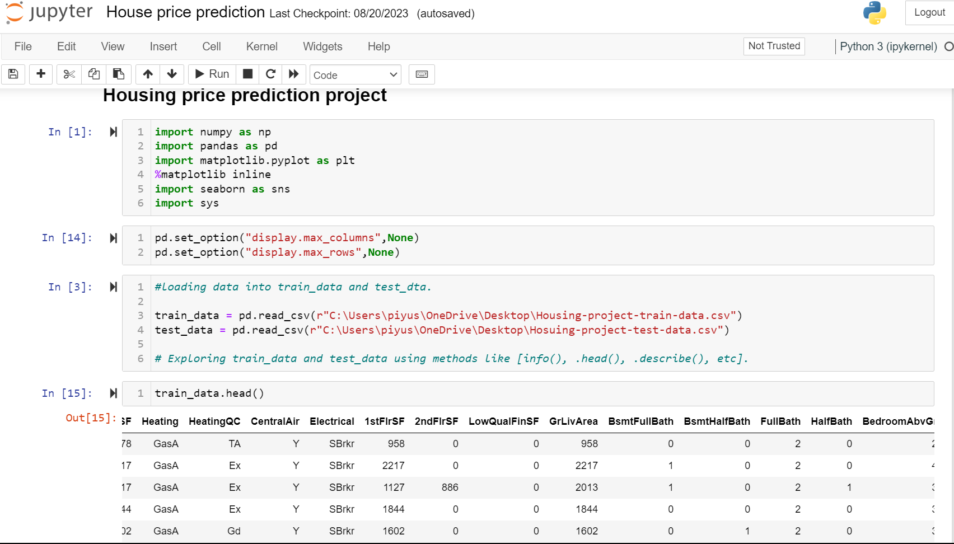

4. Exploratory Data Analysis (EDA)
Extensive EDA is done to advantage insights into the relationships among variables and the goal variable (SalePrice). Visualizations like scatter plots, histograms, and correlation matrices are used to perceive patterns and capability outliers. Insights gained from EDA guide the function choice and engineering process 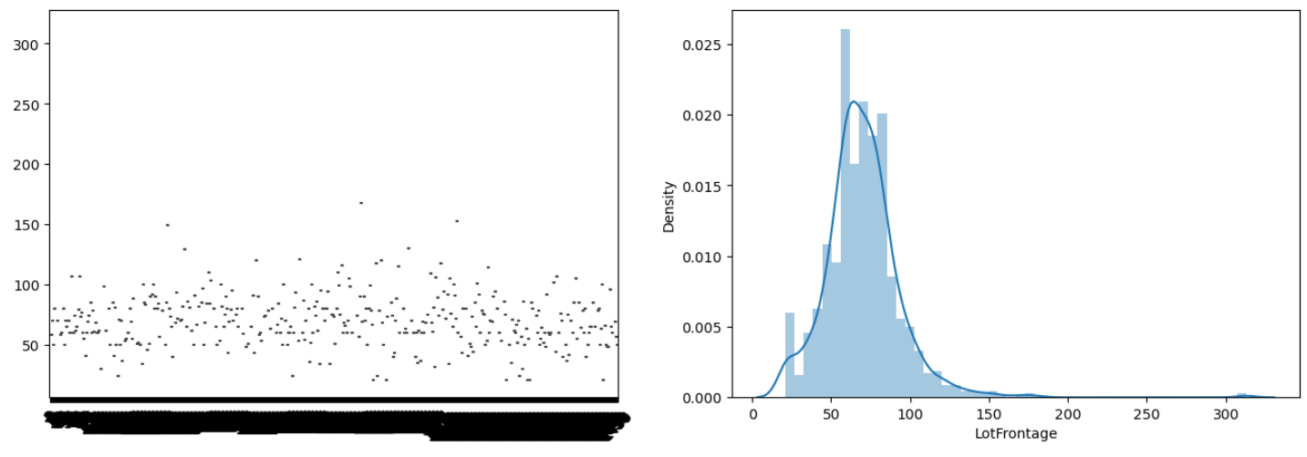

5. Feature Selection and Engineering
The importance of different variables is decided based on EDA and area expertise. Features that have a sturdy correlation with the target variable are retained, at the same time as much less applicable features are dropped. New functions is probably generated, such as general region, age of the residence, and community records. Categorical variables are correctly encoded the usage of strategies like one-warm encoding.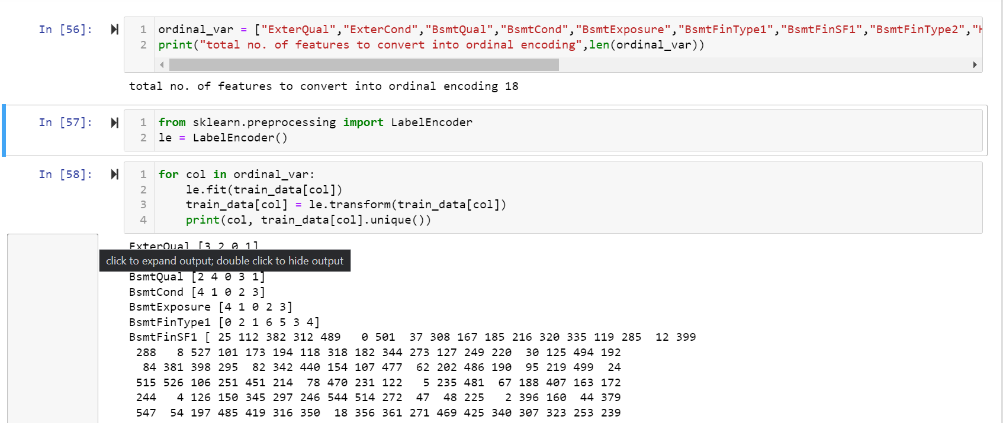

6. Model Selection and Hyperparameter Tuning
Various regression fashions are selected for prediction, which includes Random Forest and Gradient Boosting. These models are acknowledged for their potential to deal with non-linear relationships and seize complex interactions between variables. Hyperparameter tuning is accomplished the usage of techniques like GridSearchCV to discover the most effective set of hyperparameters that yield the nice performance.

7. Train-Test Split and Evaluation Metrics
The dataset is split into training and testing sets. The training set is used to train the model, while the testing set is used to evaluate its performance.
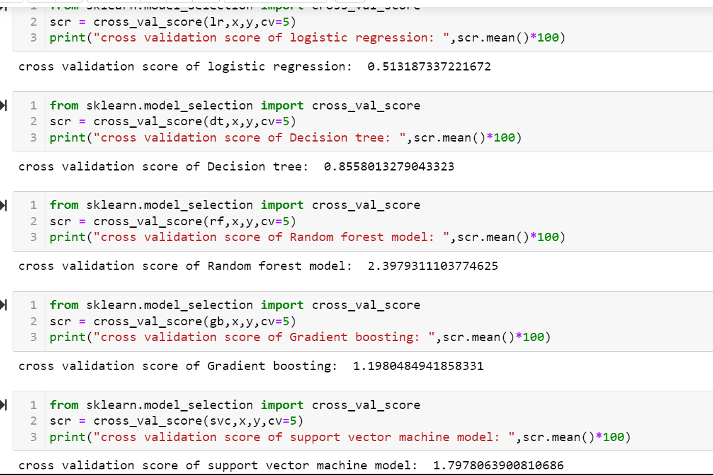
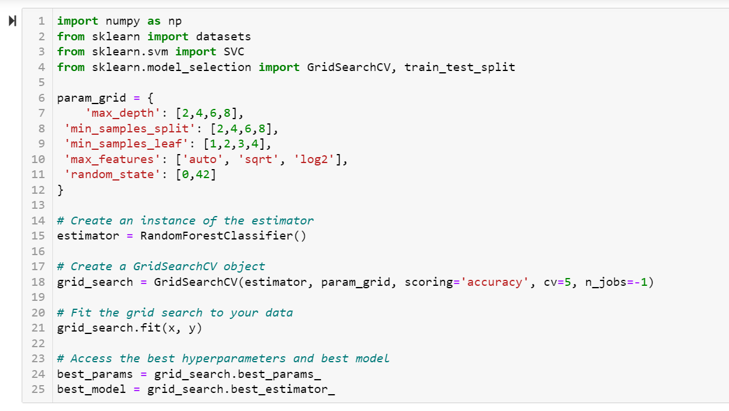
Evaluation metrics such as Mean Squared Error (MSE), Root Mean Squared Error (RMSE), and R-squared (R2) score are used to quantify the model's accuracy and predictive power.

8. Results and Model Performance
The performance of the trained models on the testing set is analyzed. Metrics like RMSE and R2 score provide insights into the model's ability to make accurate predictions. The model's performance is visualized through plots like scatter plots of predicted vs. actual prices and residual plots.
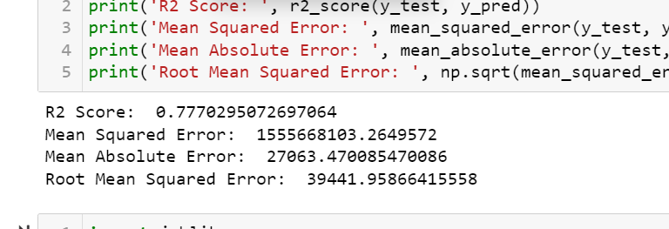
9. Conclusion
The developed housing rate prediction model demonstrates the power of machine getting to know in solving real-global commercial enterprise problems. The version appropriately predicts residence prices the usage of applicable functions , with a prediction of 77% and offers precious insights into the factors influencing pricing dynamics. The version's performance may be used to manual Surprise Housing's investment choices and pricing techniques inside the Australian housing marketplace.
10. Future Enhancements
While the modern-day model offers accurate predictions, there is continually room for development. Future upgrades should include incorporating greater superior characteristic engineering techniques, exploring different gadget learning algorithms, and thinking about ensemble techniques to in addition raise model performance.

In end, this housing price prediction model serves as a treasured device for Surprise Housing to make knowledgeable selections, optimize funding strategies, and navigate the complexities of the Australian housing marketplace. The mission showcases the capability of statistics technology and system learning in addressing real-world enterprise challenges.

